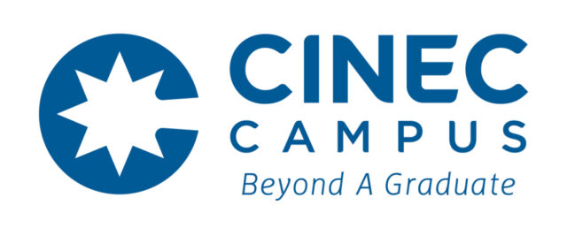

CINEC International Research Symposium 2026 (CIRS 2026)
Application Form – Three-Minute Thesis (3MT) Competition

1. Personal Information

Full Name:
Name with Initials:
National Identity Card (NIC) Number:
Current Programme of Study:
Registration Number:
Registered University and Faculty:
Date of Commencement of Programme:
Expected Date of Completion:

2. Contact Information

Email Address:
Mobile Number:
Postal Address:

3. Research Information

Research Institution (where most of the research work was carried out):
Funding Agency for Assistantship / Scholarship (if applicable):
Name of the Supervisors:
Research Title:
Area of Specialization:

4. Academic & Research Details

Academic Level: | MPhil □ | PhD □
Type of Research: | Review □ | Other (Specify)

5. Declaration by Applicant

I hereby declare that the information provided above is true and correct to the best of my knowledge. Furthermore, I confirm that the extent of research work I have conducted for my MPhil / PhD is sufficient for presentation at the 3MT competition. I agree to abide by all rules and regulations set forth by the organizing committee of CINEC International Research Symposium 2026 (CIRS 2026) – Three-Minute Thesis Competition.
Signature of Applicant: ___________________________
Date (DD/MM/YYYY):

6. Supervisors’ Endorsement
I/ We, the undersigned, confirm that the applicant named above is a registered student under my supervision and that the information provided herein is accurate to the best of my knowledge. I/ We recommend the student for participation in the CINEC International Research Symposium 2026 (CIRS 2026) – Three-Minute Thesis Competition.
** Include a separate table for each supervisor in the research.
Name of the Supervisor:
Designation:
Affiliation / Institution:
Email:
Contact Number:
Signature:
Date (DD/MM/YYYY):

